|  |  |  |
| --- | --- | --- |
| Related image | **Dr. D. Y. Patil Pratishthan’s**  **Dr. D. Y. Patil Institute of Engineering, Management & Research**  **Department of Mechanical Engineering**  **A.Y: 2020-21**  **Project Synopsys** | **Group No: 1** |
| **Domain of Project: Thermal/Design/Production/Mechatronics** |
| **Type of Project: In-house / Sponsored** |
| **Title of Project:** Modelling and Simulation of Solid Oxide Fuel Cell  **Students Name:** 1. 17101 Suyash Aher 2. 17106 Amol Bhokare  3. 17107 Omkar Bhor 4. 17133 Shubham Sawant  **Project Guide:** Prof. Ganesh Kerkal Sir  **ABSTRACT:**   * Project deals with the modeling and analysis of model of solid oxide fuel cell (SOFC) system in Program of MATLAB software. Fuel cells are known for their reliability, power quality, eco-friendly nature and fuel efficiency. Its promising technology and extremely significant in the near future. A voltage source inverter controller is developed for conversion of SOFC generation into ac grid system. The designed Mathematical model is also implemented to analyzed the output and its variations with certain parameters.   **PROBLEM STATEMENT:**   * Design mathematical model for Solid oxide fuel cell in MATALB and with the help of mathematical model analyze the characteristics of Solid oxide fuel cell like I-V characteristics curves at different temperature and fuel flow rates and output potentials at various conditions of inputs.   **OBJECTIVES**   * To study the Structure, function and principle of Operation of Solid Oxide Fuel cell, also Understanding the future scope of Solid Oxide Fuel Cell as a source of green energy and substitute to conventional fuels. * Create a mathematical Model and simulate using MATLAB to analyze the working of SOFC at various conditions.  1. Determine the I – V characteristic curve at different temperatures and fuel flow rates. 2. Determine the Nernst Potentials at different temperatures. 3. Determine the Activation losses, Concentration losses and Ohmic losses at different temperatures. | | |

# PROPOSED DIAGRAM:

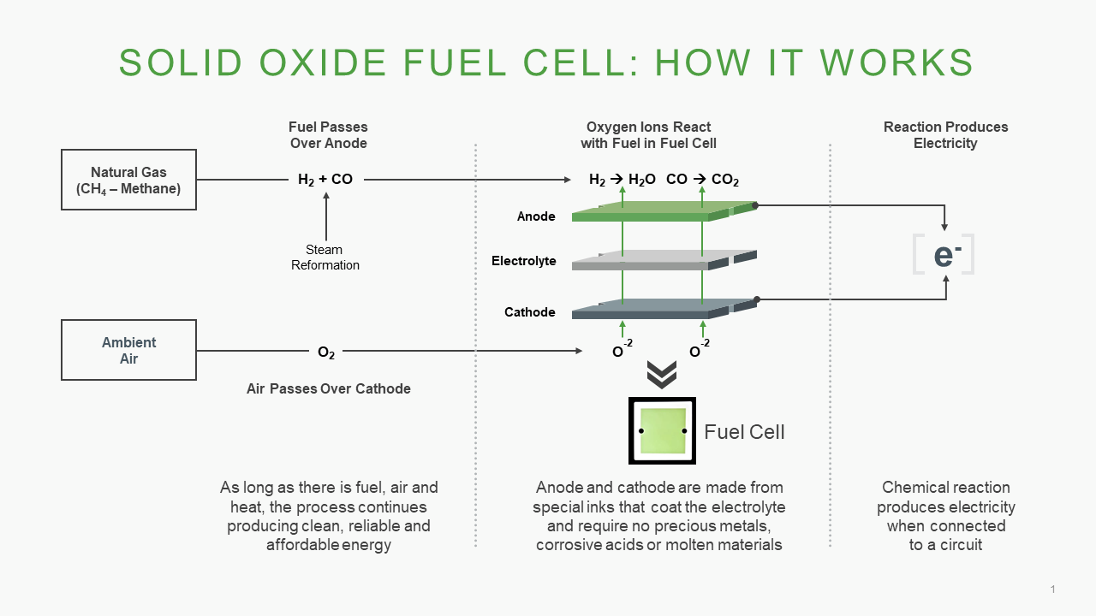

**METHODOLOGY:**

To determine the output voltage of solid oxide fuel cell we find the following parameters with the help of mathematical model of solid oxide fuel cell in MATLAB program –

**Inputs Parameters given to SOFC –**

1. Fuel flow rates
2. Current density
3. Temperature at which SOFC operates

**Parameters to find –**

1. Nernst Model of Voltage
2. Activation loss
3. Concentration loss
4. Ohmic loss

**To Find the output voltage of SOFC-**

Output voltage = Nernst Model – (Activation loss + Concentration loss + Ohmic loss)

This is How Output voltage is found for SOFC at Different Operating temperatures and different fuel flow rates and this I-V characteristics are plotted to be analyzed

# SOFTWARE REQUIREMENTS

Software Used for Designing the program to get Mathematical model of SOFC is MATLAB, We code

the program and can plot the Characteristic curves in MATALB

# CONCLUSION: